Blue and Gold Banquet
Jungle Safari Ideas

www.day-camp.shac.org/jungle-theme

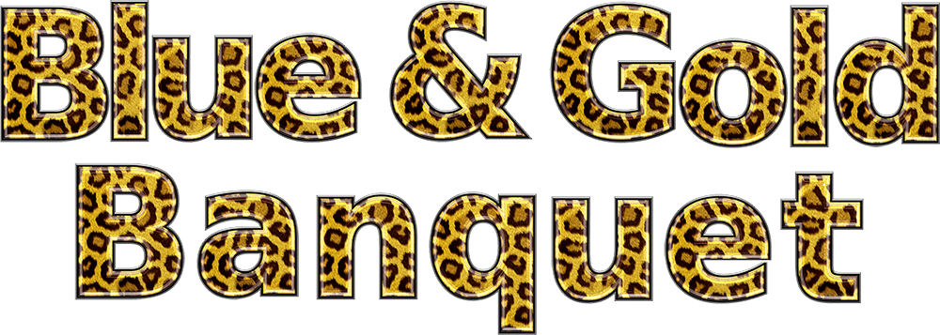
This is our first year to offer resources related to the day camp theme. Please check back for updates as we will be adding more resources at the website listed above. Please send us feedback and let us know if these resources are helpful and if we should continue this project in the future. Also, please send pictures of your event and additional ideas to darlene.scheffler@gmail.com.

Day Camp Theme: In 1914, Scouting founder Robert Baden-Powell started a Scouting program based on Rudyard Kipling’s The Jungle Book stories and targeted at younger boys in Britain.

Blue and Gold Banquets: Most packs celebrate Scouting Anniversary Week in February with a birthday party called the blue and gold banquet. It brings families together for an evening of fun and cheer. It's often the pack meeting for February.

Content  (Sources: Baloo’s Bugle Oct 2012 Jungle of Fun,  Oct 2002 Jungle of Fun, 1998 Safari; BSA Program Helps Oct 2009 Jungle Safari)  Blue and Gold Banquet  Cheers  Skits  Songs  Decorations  Program  Additional ideas are available at www.day-camp.shac.org/jungle-theme  Gathering Activities  Opening Ceremonies  Audience Participation  Games  Closing Ceremonies  Cubmaster Minute  Theme Related Stuff | Blue and Gold Placemats  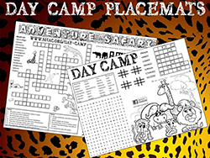  Free, customizable placemats are available for packs to use at blue and gold banquets and den leaders to use during den meetings to help promote day camp. Download placemats at  www.day-camp.shac.org/jungle-theme

Jungle Safari Blue and Gold Banquet

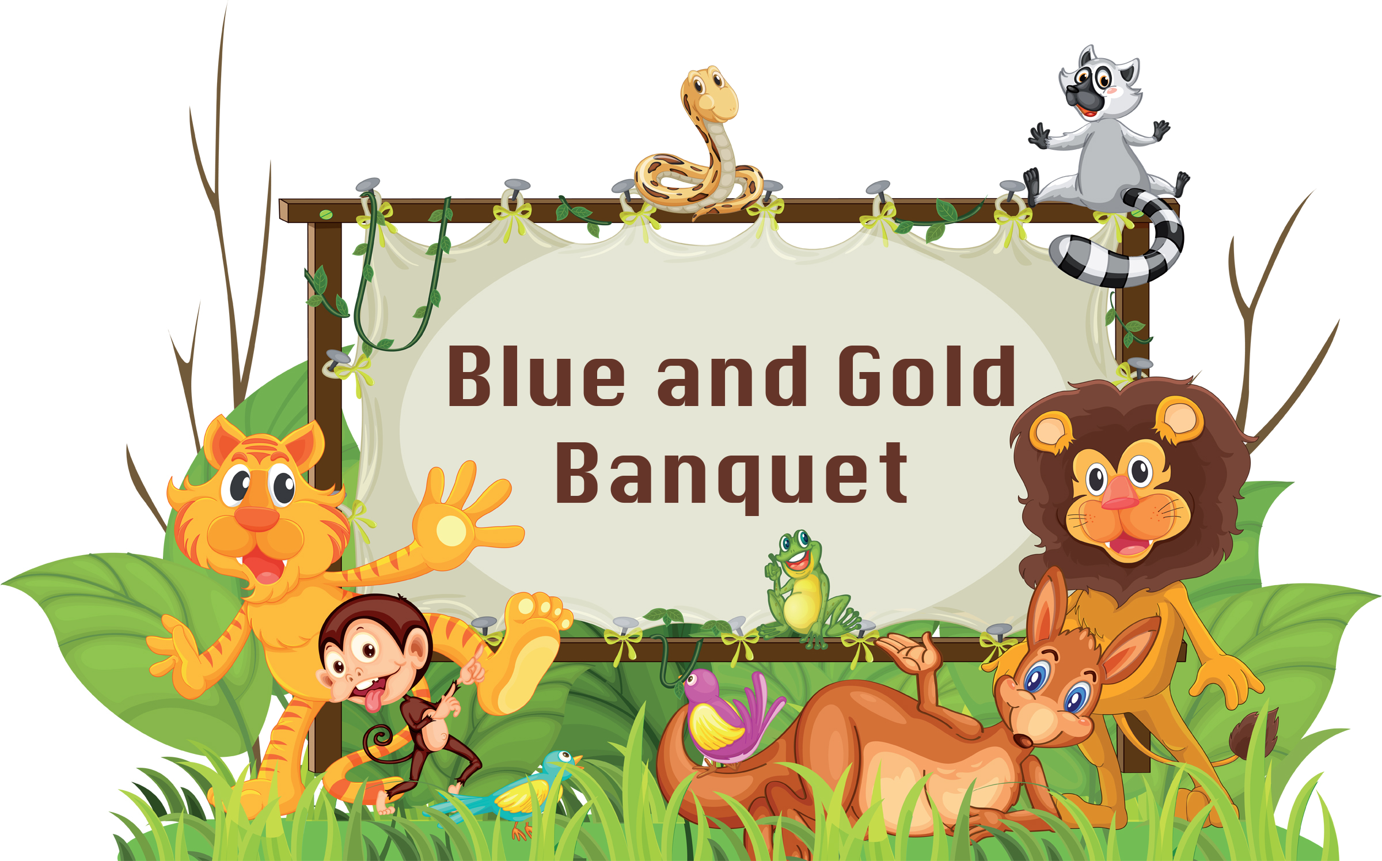
Welcome
Cubmaster (wearing safari gear): Welcome the Cub Scouts, parents and leaders. Recognize special guests. In the earliest days of Boy Scouts, the founder, Robert Baden-Powell, was overwhelmed with requests from younger boys and their parents that he provide a program suitable to younger boys. Baden-Powell knew that he had to find a theme for the program so that it would be a program just for them and not a Boys Scouting-in-miniature program. In trying to come up with the program theme, he thought of Rudyard Kipling’s Jungle Books and knew that this was what was needed. Baden-Powell wrote to Rudyard Kipling and asked permission to use his books as the basis for the younger boys’ program. Kipling, a solid supporter of Boy Scouts, the father of a Boy Scout, and the author of the official Boy Scout song gave his permission. From this come the roots of Cub Scouting around the world. Tonight, as we have our fun and celebrate the work our Cub Scouts have done, let’s remember our jungle roots. Now let’s get the meeting into full swing and have some fun as we monkey around!

Opening Ceremony
Setting – 8 Scouts in a line; six should be holding the letters S-A-F-A-R-I with the appropriate verses on the back. Use poster board and make the letters our of sticks or fake leaves.
Scene – Scouts stand in a line spelling SAFARI. One Scout without a letter stands on each side of this line.

Hint- have the den practice multiple times before the banquet. Teach the boys to talk slow, look up at the adience and how to talk into the microphone or talk loud project their voice to the back of the room. Write the words on the back of the posters, but make sure Scouts don’t talk down when reading.
- Jungle Safari is our theme for the blue and gol banquet. Safari means searching, and we are searching for some fun!
- S is for Scouting; we’re searching the trail. For adventure and fun, we surely can’t fail.
- A is for Action; we like to play games. But being good sports is part of the aim.
- F is for Fun, we like being Cub Scouts! It’s the best thing there is, without any doubt.
- A is for Adventure, and trying new things. We give it our best when we try anything.
- R is for Ready, we’re ready to go! On field trips, or camping, or the yearly Scout Show.
- I is for Ideals, that we learn here in Scouts. Of loyalty, country, and freedom we shout.
- Please join us in saluting our country’s symbol of freedom by saying the Pledge of Allegiance.

Pledge

Invocation

Webelos or Representative from Chatered Organization: We approach Thee, and ask Thee to join Thy love for the Cub Scouts. Give us the vision to see our duty and the courage to perform it. Teach us to walk together in the spirit of brotherhood, so that we are true to Thee. Fill our hearts with appreciation, and respect for all living things, those that live in the waters, and those that crawl upon the land. so that we might live together in harmony and in peace. Help us to obey the Scout Law and Scout Oath. Our dear Heavenly Father, we ask a special blessing on the families in our Cub Scout pack. We ask a special blessing on each Tiger, Cub Scout, and Webelos as they give service to other people. Guide their steps as they grow into men, and help them as they do their duty to You and our country. Bless our food and the people who have prepared it. Amen

Dinner

FOS Presentation
Advancement Ceremony
Jungle Tour
Equipment: Sound effects of a car or truck motor, prerecorded wild animal noises, Cubmaster dressed in safari attire. Recording of motor will be turned on and off at designated places, while the animal recording can run continuously after the tour has started.
Cubmaster: Ladies and gentlemen, welcome aboard our Cub Jungle Tour Bus. I hope you have all signed the waivers that would free our pack of any responsibility for accidents or unexpected dangers. It’s a jungle out there, you know. Please remain seated at all times with your seatbelts securely fastened. Please keep your hands and feet inside the bus at all times and DON’T feed the animals, no matter how much they beg. Now, let’s begin our tour. (Start the motor recording and the animal noise, and play both softly in the background.)
On your left, we will be coming to the watering hold of the Bobcat. He has done much to get himself this far along the trail. He has performed eight tasks that teach him how to be a good Cub Scout. (Stop the motor recording and hand out any Bobcat awards. When finished, start the motor recording again.)
Now, we come to our prowling Tigers. (The Tiger den leaders come forward to help hand out awards. Hand out the Tiger awards to parents to present to their sons. Lead a cheer. Start recording again.)
Next, we come to the Wolf den. (The Wolf den leaders come forward to help hand out awards.) Mother/Father Wolf has nurtured his/her little cubs until they are strong enough to work on their own in some things. They have learned many new things as they worked on important lessons that teach them how to be good Wolves. (Stop the motor recording and hand out the Wolf awards to parents to present to their sons.. Lead a cheer. Start recording again.)
Over here on our right is the feeding ground of the Bears. Be careful, they are always hungry and will beg for food with long suffering faces. But Baloo, their teacher, has taught them the Scout Law. (Bear den leaders come forward to assist.) Baloo has grown wise and finds that if he makes the Bears work a little on their own, they can accomplish much—even without food. (Stop motor recording and hand out Bear awards to parents to present to their sons. Lead a cheer. Start recording again.)
Looking out on the plains ahead of us, you can see a herd of wild Webelos. They may appear to be grazing lazily, but with a little motivation, they can create a stampede of activity, working together to achieve much. Their leader can really call them to action as they do new and exciting things each month. (Webelos leaders come forward to help hand out awards. Stop motor recording and present the Webelos awards to parents to present to their sons. Lead a cheer. Start recording again.)
This concludes our tour of the Cub Scout Jungle. We have made it safely back to our blue and gold banquet. Thanks for helping to make this tour such a success; we appreciate your support of our pack. (One final cheer for all!!)

More Advancement Ideas
- Make a palm tree from a carpet tube and green butcher paper. Stick in a paint bucket filled with rocks. Wrap a paper snake around the tree. Attach awards to little cutouts of snakes on which you write, "You are such a sssss-super Sssss-scout, You'll go down in Hissssstory. Congratulations on earning your....
- Attach awards to different jungle animals pictures. Display around room. Call on boys who are receiving awards to pick one of the animals. Call that boy up to get his award.
- Put awards in a box. Dress in a safari costume. Have two leaders carry in the large box suspended from two long poles.
- Crocodile- Put crocodiles in a wading pool. Boy retrieves his crock with his award inside. (Use Green plastic soda bottles decorate.)
- Attach awards to bananas. Display bananas on a large poster of a gorilla or better yet, have someone come in dressed as a gorilla. carry awards in containers made to look like bananas!

Song

Den leads a song. Assistant Cubmaster then conduct a cheer. Hint:distribute copies of the song, so everyone can join.

Leader Recognition
Materials – pretend binoculars mounted on a display with the words – "Thanks for bringing adventure to our pack with your remarkable views."
Committee Chair - Every month at our pack meetings, we recognize the Cub Scouts who have received awards. Today, we would like to recognize our leaders. Call up all den leaders and committee members..

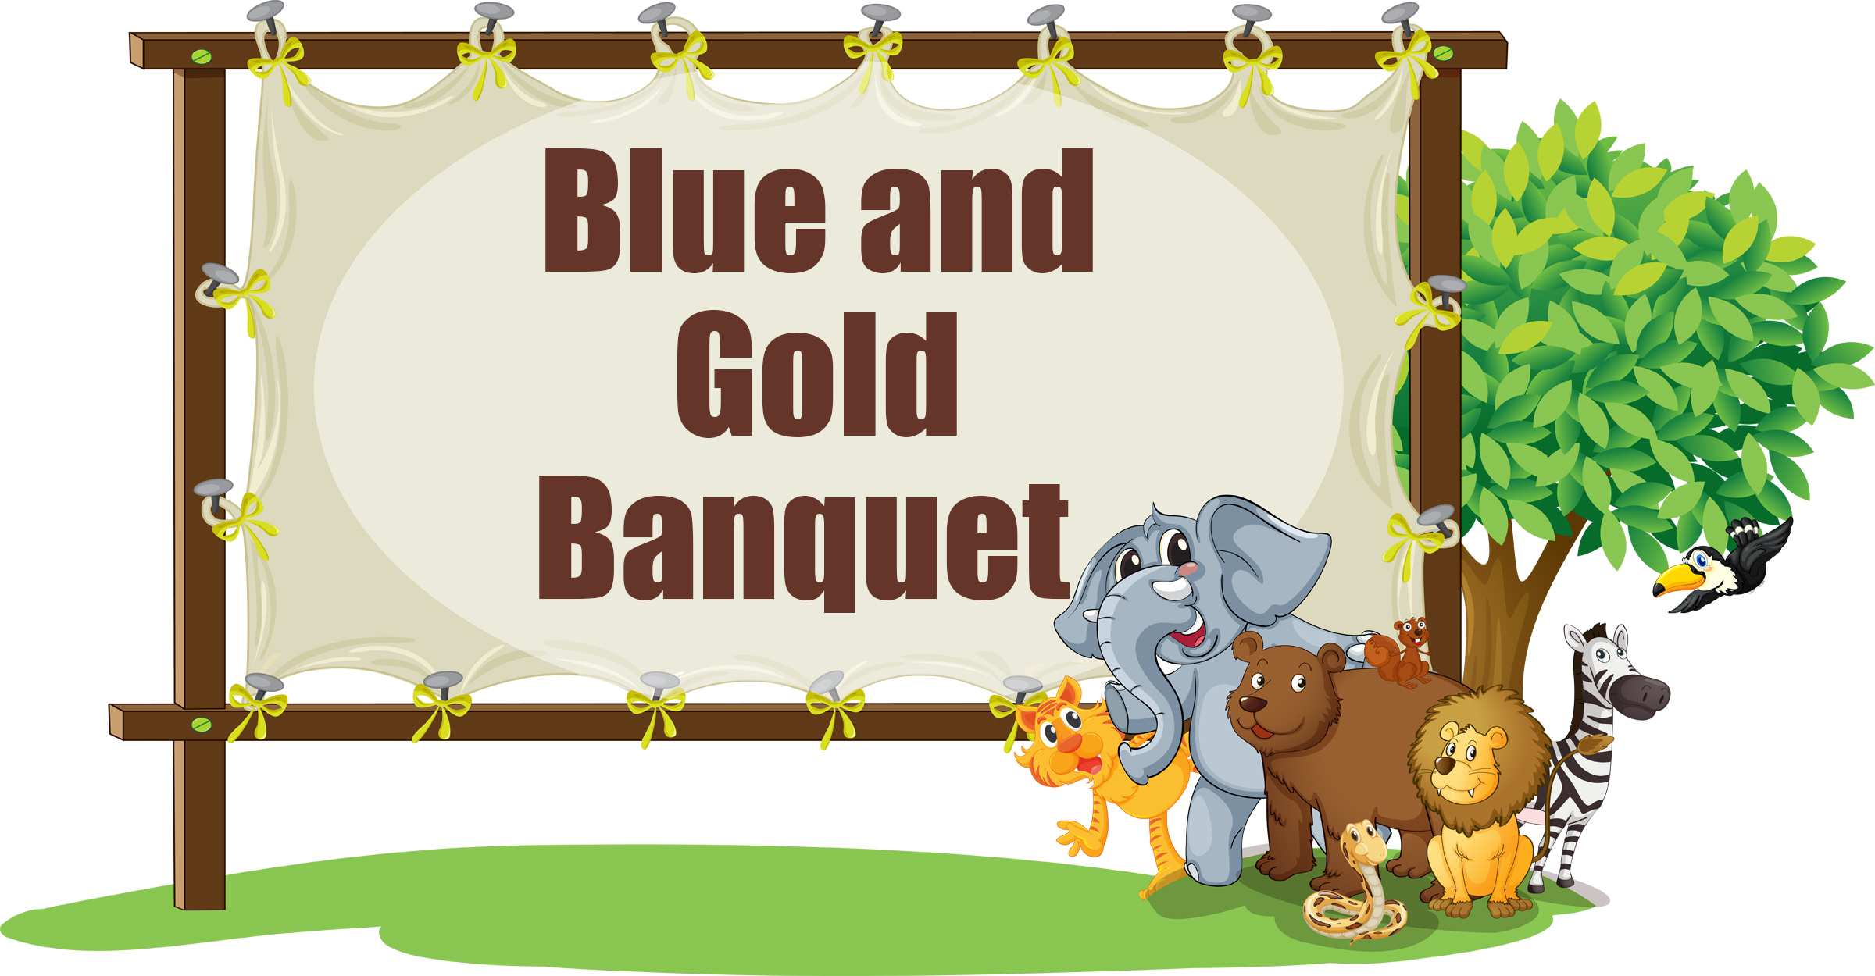
There are eyes upon you and they're watching night and day.
There are ears that quickly take in every word you say.
There are hands all eager to do anything you do,
And a young man who's dreaming he can be a leader, too.
You're a Cub Scout’s idol. You're one of the very best.
In his mind, you’re somehow better than the rest.
He believes in you devoutly, and in everything you do,
He is waiting for the chance to act just like you.
There's an energetic young man who believes you're always right.
And his ears are always open; and he watches day and night.
You are setting an example every day in all you do,
For a Cub Scout who's waiting to grow up to be like you.
Conduct a cheer.
Cubmaster – We have some leaders and parents with us tonight who have forged a path for our pack through the jungle of training and planning and we would like to thank them for taking the time to make sure they are presenting you Cubs with the very best program. We have the binocular award for them – for always keeping a close eye out for opportunities. Present any leader training awards.

Skit

Den conducts a skit. Assistant Cubmaster then conducts a cheer. Hint:have the den practice multiple times before the banquet. Teach the boys to talk slow, look up at the adience and how to talk into the microphone or talk loud project their voice to the back of the room.

Cubmater Minute
We would like to recognize and thank the blue and gold banquet committee members for their effort and hard work. Wow! What an exciting adventure we had tonight with our Jungle Safari. We met some pretty interesting characters along our trek and we congratulated a lot of Scouts for their awards. Scouting can be a real adventure, whether or not we’re in the jungle. Lord Baden-Powell called Scouting, “fun with a purpose.” There is a definite purpose to the awards our Scouts are earning. They are learning new skills and developing a sense of character so that when they enter the real jungle of being grown up, they will be prepared. I, for one, am very proud of their accomplishments and I hope they are proud, too, and will continue along the safari trail of Scouting.

Closing Ceremony
Setting – 6 Cub Scouts each with one letter from S-A-F-A-R-I (If you used the SAFARI opening, recycle the letters)
- S is for Scouting spirit
- A is for Aims and Methods
- F is for Friends and making memories
- A is for Awards and advancing on the Scouting trail
- R is for Really fun Scouting activities
- I is for I had a great time tonight!
All: Thanks for coming to the blue and gold banquet and good night!

Blue and Gold Banquet Resources

The purpose of the blue and gold banquet is to celebrate the pack's anniversary, thank pack leaders and other adults who have helped the pack, and inspire the leaders, Scouts, and parents. The banquet can be like a regular pack meeting,
with songs, skits, stunts, and awards. Or it can be something different and a little more special. Your pack may decide to bring in an entertainer such as a magician or a storyteller. Or you could have a video or slide show of what the pack did over the past year. A good banquet needs lots of planning.
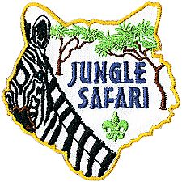
Careful planning is necessary for the banquet to be successful. Most packs begin planning at least two months in advance. The pack committee should recruit a banquet chair, who in turn may select others to carry out the responsibilities of the program, such as making physical arrangements, handling invitations, choosing a theme, etc. Try to involve as many people as possible, but avoid giving den leaders too many additional responsibilities because it may distract them from their duties to their dens.

A detailed plan for the blue and gold banquet, including a planning calendar, sample agenda, and suggested program activities, is available in the Cub Scout Leader How-To Book.

Editable, Word version of this document: www.day-camp.shac.org/jungle-theme

SHAC Pinterest page: www.pinterest.com/samhoustonbsa/day-camp-jungle-theme/

Jungle Themed Placemats: www.day-camp.shac.org/jungle-theme

Banquet Planning: www.skcscouts.org/wp-content/uploads/2013/06/Blue-Gold-Planning-Guide.pdf

Banquet Planning: www.ocbsa.org/wp-content/uploads/2011/06/Blue-Golf-Banquet-for-Website.pdf

STUNTS & APPLAUSES

CHEERS
Alligator Cheer
Everyone puts their arms out in front of their body palms together, open the jaws of the alligator by spreading the arms in vertical motion, slowly, then snapping the jaws shut very quickly. Do this three times!
Banana Cheer
“Peel bananas, peel peel bananas!” (Repeat twice. Pretend you’re peeling a banana.) “Go bananas, go go bananas!” (Repeat twice. Jump around, spin in a circle, punch fists in the air.)
Bear Hug Cheer
Put arms around your own shoulders and give yourself a big hug.
Bees in this Beehive Cheer
Instruct everyone to start humming.
Then as you raise your hands the humming gets louder.
When you lower your hands the humming gets quieter.
Bobcat Cheer
Stand up, give a loud “Meow!” three times.
Disco Mosquito Cheer
Slap 4 times—once on each cheek, once on each arm,
While singing “Oh, oh, oh, oh!”
Then point finger up and down
while singing, “Eaten alive! Eaten alive!”
Elephant Cheer
Let your arms act as trunk. Wave it in front of your face. Raise your arm up and roar.
Frog Pond Cheer
Divide into three groups.
Group 1, using high voices = “Tomatoes, tomatoes, tomatoes” Group 2, with medium voice = “Potatoes, potatoes, potatoes!”
Group 3, with deep bass voices = “Fried bacon, fried bacon, fried bacon!” Rehearse with each group; then add one group at a time.
Jungle Cheer
Assign cheers to roups.
Tiger Cubs: Roar like a tiger—RRRRR!
Wolf: Howl like a wolf—Ah-ooooo!
Bear: Growl like a bear—Grrrr!
Webelos: We’ll BE Loyal Scouts!
Cub Scouts: The sounds they used earlier
Moms: Screech like a hawk—Eyaw! Eyaw!
Dads: Yell like a monkey—Eeeek! Eeeek!
Other family members: Hiss like a snake—Hsss! Hsss!
Leader: Thank you to all the inhabitants of our jungle pack. Let’s give them a jungle cheer!
Giraffe Cheer
Stretch your neck up, stand on tip toes, “That was out of site!”
Monkey Cheer 1
Semi squat position. Raise hands to ribs under armpits.
Make motions of scratching and
Hop up and down saying, "Eeeek, Eeeek!"
Monkey Cheer 2
Ooo, Ooo, Ooo (while acting like a monkey)
Rainforest Cheer
Divide audience into 5 groups. Assign each group a part -
- Rubs palms together (wind)
- Snaps fingers slowly (first drops of rain)
- Claps hands, vary rhythms (steady, light rain)
- Slaps thighs (heavy rain)
- Stamps feet (downpour)
The Cubmaster points to the first group as they begin their action. Each group, once started, continues until the Cubmaster points at them a second time to stop. After the first group starts, the Cubmaster points to the second group, and then the third, and so on until all the groups are participating in a loud and crashing rain storm. Then the Cubmaster stops the groups in reverse order as the storm dissipates and calm returns.
Rainforest Cheer Variation
Have the boys choose whether they want to make the sounds of rain, birds or insects in the jungle. You might even add larger animals. Make sure you have a good mix of sound – boys can switch places so everyone can do various sounds. Each sound should stand in the same section. Have each section practice once. Now point to the various sections and have them produce their rainforest sounds. Have them get softer or louder by using hand signals. Try having everyone make their sound at the same time, or having one section louder than the others. Try making “daytime” sounds and “nighttime” sounds. What sounds would you hear if a predator was coming close? You could also check out a National Geographic or nature video that has those sounds and compare them to your own orchestra. Tape the sounds of your “orchestra” and use it for background music at the pack meeting.
Taming of the Wild Lion Cheer
Simulate having a chair and whip in hand.
Hold chair out and crack whip and yell "Back, back, back!"
Then Yell - "Help, Help, help, the lion has the whip.
Tarzan Cheer
“I like bananas (pantomime eating a banana), coconuts (throw a coconut), and grapes (eat grapes.) That’s why they call me (yell next part) Tarzan of the Apes!”
Tiger Cheer
That was G-R-R-R-R-R-R-R-E-A-T!
Tony the Tiger Cheer
Grrrrreat!
Watermelon Cheer
You take a big bite of a watermelon,
Chew it up good and now
You spit out the pits like a machine gun
Woodpecker Cheer
Knock on your chair 5 times.
Woody Woodpecker Cheer
http://www.youtube.com/watch?v=x22lCxYA-fs&feature=related
Zebra Cheer
“Zee-bra, zee-bra, ZEEEEEEE-BEST!”

Cub Scout Jungle Cheer
Cubmaster: Here we are in the jungle is everyone here, Tiger Cubs stand up and cheer.
Tiger Cubs: (Growling, stand up) (Cheer)
Cubmaster: Here we are in the jungle is everyone here, Wolf Cubs stand up and cheer.
Wolf Cubs: (Howling, stand up) (Cheer)
Cubmaster: Here we are in the jungle is everyone here, Bear Cubs stand up and cheer.
Bear Cubs: (Growling, stand up) (Cheer)
Cubmaster: Here we are in the jungle is everyone here, Webelos stand up and cheer
Webelos: (Stand up and give Cub Scout Salute) "We'll Be Loyal Scouts."
Cubmaster: Here we are in the jungle is everyone here, Akela stand up and cheer.
Leaders and Parents: (Stand up) (Cheer)
Cubmaster: Here we are all, in the jungle, Akela lead us safely on.
All: (Repeat their cheer)

DEN YELLS
Yell 1: 2, 4, 6, 8,
Jungle Adventure we can’t wait,
(Make an animal sound)

Yell 2: Jungle Adventure here we come,
Den ___, Den ___ ,
Is # one!

Yell 3: On a safari we shall go, What will we see?
No one knows!
Go Den ___!

Yell 4: Lions, Tigers, Cheetahs too,
Den ___, Den ___,
Here’s looking at you!

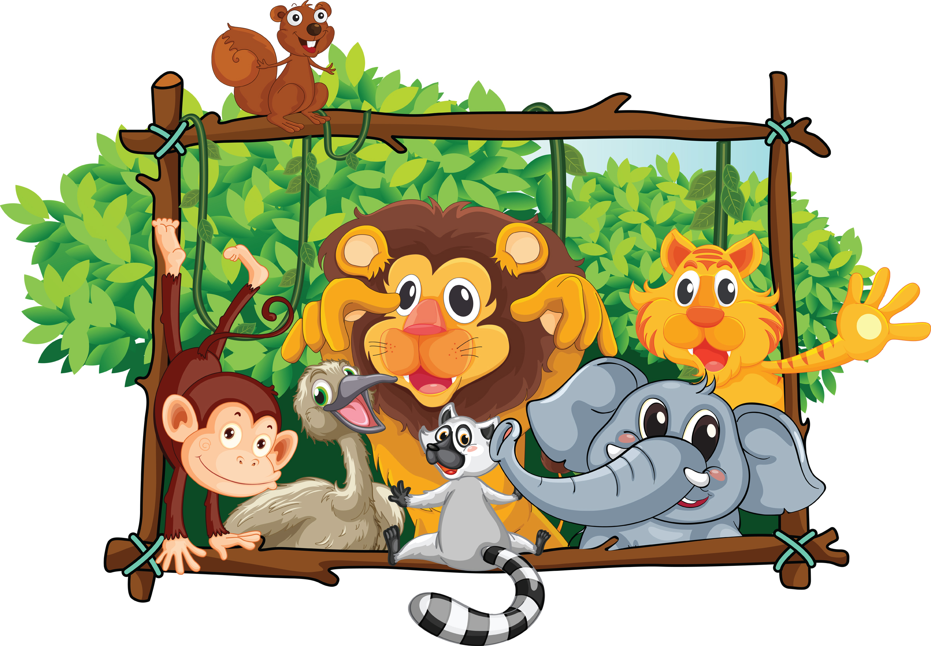

RUN-ONS
Cub #1: What did the mother turtle say to her baby turtle?
Cub #2: You should come out of your shell!

Cub #1: What does a snake wear with a tuxedo?
Cub #2: A BOA tie!

Cub #1: What wild animals are best dressed?
Cub #2: TIE-gers!

Cub #1: Which side of a cheetah has the most spots?
Cub #2: The outside, of course!

Cub #1: What do elephants do for fun?
Cub #2: They tell “people” jokes!

Cub #1: What do you get when you cross a parrot with a centipede?
Cub #2: A walkie talkie!

Cub #1: What is a crocodile’s favorite game?
Cub #2: That’s simple – SNAP!

Cub #1: What’s the difference between a hurt lion and a wet day?
Cub #2: One pours with rain, the other Roars With Pain!

Cub #1: What time is it when an elephant sits on your fence?
Cub #2: Time to get a new fence!

Cub #1: Where do wild animals play?
Cub #2: On the jungle gym!

Cub #1: Why are you wearing that green string?
Cub #2: To keep the lions away.
Cub #1: But there are no lions around here.
Cub #2: See how well it works?

Cub #1: How can you lift an elephant?
Cub #2: Put an acorn under him and wait twenty years.

Cub #1: What business did the father ape want his son to go into?
Cub #2: The monkey business!

Cub #1: I’m a great jumper
Cub #2: I can jump too. I bet I can jump higher than that tree.
Cub #1: This I gotta see. (jumps a little hop)
Cub #2: That’s higher than a tree?
Cub #1: Sure, that tree can’t jump at all.

Cub #1: What’s the best year for a kangaroo?
Cub #2: Leap year!

Cub #1: (runs in yelling) They’re after me! They’re after me!
Cub #2: Who’s after you?
Cub #1: The monkeys! They think I’m bananas!

Cub #1: Can you name 9 animals from Africa?
Cub #2: Sure, 8 elephants and a lion.

Cub #1: Hello, operator. I’d like to speak to the King of the Jungle.
Cub #2: I’m sorry sir, but the lion is busy.

Cub #1: What’s worse than a giraffe with a sore throat?
Cub #2: That’s a hard one.
Cub #1: A centipede with athlete’s foot.

Cub #1: Why can’t you get two elephants into a pool at the same time?
Cub #2: They only have one pair of trunks.

Cub #1: What do you get when you cross a tiger with a parrot?
Cub #2: I don’t know, what?
Cub #1: I don’t know either, but when it talks, you better listen!

Cub #1: Ask me if I’m a rabbit.
Cub #2: Okay. Are you a rabbit?
Cub #1: Yes. Now ask me if I’m a beaver.
Cub #2: Are you a beaver?
Cub #1: No silly. I already told you I was a rabbit.

Cub # 1: Did you hear about the tiger who ate a lemon?
Cub # 2: No, what about him? Cub # 1: He became a sour puss.

Cub # 1: Do you know why lions roar?
Cub # 2: Of course. Because they would feel silly saying, “Oink!”

Cub # 1: I just spotted a leopard.
Cub # 2: Don’t be silly they grow that way.

Cub # 1: What do you get when you cross an ape with a tiger?
Cub # 2: Tarzan stripes forever.
Cub # 1: What do you do with a blue elephant?
Cub # 2: Cheer him up.
Cub # 1: I saw some panther tracks about a mile east.
Cub # 2: Good, which way is west?
Cub # 1: Did you have any luck hunting tigers?
Cub # 2: Yes, I didn’t meet one!
Cub # 1: Why are you wearing that green string around your finger?
Cub # 2: To keep the lions away.
Cub # 1: But there are no lions around here.
Cub # 2: See how well it works?

Cub # 1: How do you know when an elephant likes you?
Cub # 2: It gives you a stamp of approval.
Cub # 1: How fast must you run if a tiger is chasing you?
Cub # 2: One step faster than the tiger.
Cub # 1: Why do elephant walk so slowly?
Cub # 2: Because they don’t have jogging shoes.

Cub # 1: What did the cheetah say after he ate an ice cream cone?
Cub # 2: That hit the spot!
Cub # 1: What goes through the jungle without making a sound?
Cub # 2: A trail.
Cub # 1: What kind of animal eats with his tail?
Cub # 2: All kinds. They can’t take them off.
Cub # 1: Why does a giraffe eat so little?
Cub # 2: He makes a little go a long way.

Cub # 1: Where do wild animals like to play?
Cub # 2: On the jungle gym

Cub # 1: With what big cat should you never play cards?
Cub # 2: The cheetah!

Cub # 1: Why do elephants paint their toenails red ?
Cub # 2: So they can't be seen when they hide in cherry trees.

Cub # 1: How do you know you have had elephants in the fridge?
Cub # 2: Footprints in the butter.

Cub # 1: How do you get two elephants in a pickup truck?
Cub # 2: One in the cab, one in the back.

Cub # 1: How do you get two mice in a pickup truck?
Cub # 2: You can't ... it's full up with the elephants.

Cub # 1: Why do Rhino’s wear ripple‐soled sneakers?
Cub # 2: To give the ants a chance

Safari Knock Knock
Cub #1: Knock Knock…Who's there !
Cub #2: Safari !...Safari who ?
Cub #1: Safari so good !

Cub #1: Knock Knock…Who’s there?
Cub #2: Fashion….Fashion who?
Cub #1: Fashion your seat belt – we’re going on a great ride!

Cub #1: Knock Knock…Who’s there?
Cub #2: Owlet….Owlet who?
Cub #1: Owlet you go first through the jungle!

SKITS

All About Animals Skit
Cast: Jerry, Jimmy, Johnny and Jack.
Scene: Jerry is reading. He turns the pages of his book slowly, one by one as the others enter.
Jimmy: Hi, Jerry. What are you doing?
Jerry: (Not looking up) Reading a book about animals.
Jimmy: It must be a good book. (He sits down and picks up a book and starts reading.)
Johnny: (Enters) Hi, Jerry. What are you doing?
Jerry: (Not looking up) Reading this book. (Closes book) Now I know all about animals.
Jack: (Enters) Hi, guys. What are you doing?
Johnny: Jerry’s been reading this book. He says he knows all about animals.
Jack: Okay then, tell me, what animal can jump higher than the Empire State Building?
Jerry: (Thinks) I’ll have to look it up. (He looks in book)
Jimmy: I don’t think any animal can jump higher than the Empire State Building.
Johnny: (To Jerry) And I thought you knew all about animals!
Jerry: (Sheepishly) So did I. So, what animal can jump higher than the Empire State Building?
Jack: All of them. The Empire State Building can’t jump!

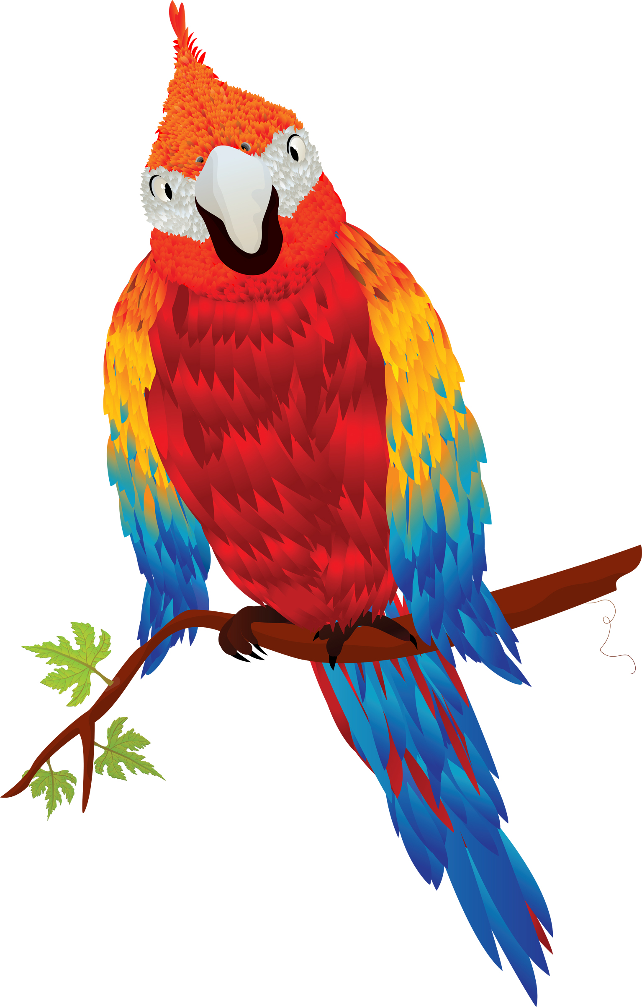

Cub Scout Safari
Set-up: 5 Scouts and Camp Director driving a cardboard jeep with safari hats on
CD: We're so glad you could join us on our jungle adventure tonight. Our fearless leader (CD's name) will be driving our jeep. But as with any trip there are a few instructions you must hear. (2 boys jump out of the jeep and start chasing each other)
1st passenger still in jeep: “Johnny Lion, what are you doing?” One of the boys running: “I'm chasing a hunter around a tree.”
2nd passenger still in jeep: “How many times have I told you not to play with your food.” (All go back to jeep)
Next Cub Scout gets out of jeep and says:
“Bobby had a kitten, Tommy had a pup, Johnny had a crocodile, That ate the others up.”
3rd passenger (climbs out of jeep and looks at the 4th passenger): “What has fifty legs, big blue eyes on stems, and a red body with green stripes?”
4th passenger: “I don't know. What?”
CD: “I don't know either, but it's crawling up your shirt right now.”

Cub Scout Safari Skit
These puppet patterns can be enlarged to make life-size, or at least Cub-sized “costumes” cut out of cardboard. Circles shown are cut out for the boy’s head and arms, about elbow height. Boys can then paint them to wear in the skit, during run-ons, or as they give a “bio” of who they are, where they live, what they eat, who eats them, and how they protect themselves.
For younger boys, you could have the boy say only the underlined part and the narrator could fill in the rest.

Narrator: This month, the boys from our pack went on a real adventure – an animal safari. Who’s this first animal?
Hippo: I live in the water and on land – I don’t really swim, but I spend much of my time in the water, walking along the bottom. I am the most dangerous animal in Africa for humans. I’m the hippo and I can hold my breath longer than any other animal on safari.
Giraffe: Personally, I like to get above everyone else. My long neck lets me eat the most tender leaves from the very top of the tallest trees. I may not look very graceful when I bend to get water, but I can cover lots of ground with my long legs – and deliver a dangerous kick. My neck is so long that it has to sway as I run to keep my balance – I’m the giraffe.
Cheetah: I can run much faster than the giraffe – in fact, I’m the fastest animal in the world. – the cheetah. But antelope often escape because they can run for longer times than I can. Even lions are afraid of me if they have young cubs.
Lion: I am still the King of the Jungle, the lion. I can blend right in to the grasses where I live, and walk softly and slowly without my prey even knowing I am coming close. Actually, I just watch as the females run down my dinner for me! Like all cats, I love to sleep and rest for about 20 hours a day!
Elephant: I am so heavy and strong that my Indian cousins are used to haul people and very heavy loads-I’m the elephant. In the jungle, I uproot whole trees to get at the food I like best. I can use my trunk, which has many muscles, to pick up small items. But my sound is not small – the loud trumpet sound I make can be heard for miles.
Chimpanzee: You may have seen me in a zoo, and laughed at the funny faces I sometimes make – I’m the chimpanzee. In the jungle, I live in a large family group and take turns grooming my friends. I’m really clever – I put a stick into an anthole, and when the ants climb on, I pull out the stick and eat them.
Zebra: I may look like a horse to you, but I’m the zebra, and my stripes have a special purpose. Each species of zebra has a different pattern of stripes, and the black and white colors blend into shadows, helping me hide from my enemies. I can also kick and bite in a fight.
Narrator: Well, our Cub Scouts certainly “captured” a lot of jungle animals on their safari this month. Each one has a special place in the jungle – the variety is wonderful. Some of these animals are endangered by over-hunting and loss of habitat. Let’s encourage humans all over the world to do their part to keep our safari animals safe!

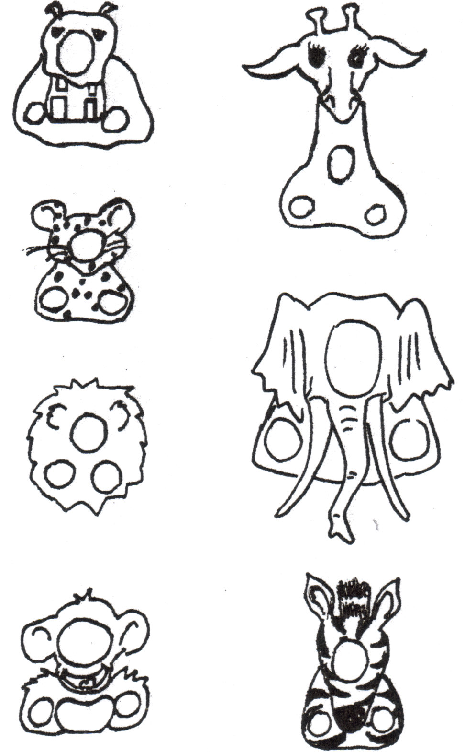

Did You See That? Skit - Classic Version
Stanley, (In a strong European accent) Hello there, I am Arthur Stanley Livingstone, the world famous ornithoptitologist! That means I watch birds, you know. And we are all going on a bird study trip today
Boys, (Not really paying attention) H'lo
Stanley We are here today on location in the midst of the African rain forest, and we should see some very rare birds indeed! I can hardly contain myself. It is so exciting isn’t it?
Boys Oh. Uh, yeah
Stanley slowly and carefully stalks along, looking around,
listening for the slightest peep. Boys shuffle after him.
Stanley, (Turning around, staring with wide open eyes for a second, then jumping up and down)
Did you see that!! Did you see that!!
Boy #1 - Er, what?
Stanley You mean you missed it?
Boy #1, (Pauses, then admits it) Uh, yeah
Stanley "Well! My word. Todd, that was a very rare bird, the Oohweeoo-plit-plit-plit-awaah. And you missed it. It's named after it's call, you know."
Boy #1 Mmm, what's it sound like?
Stanley, (After a suspenseful pause) Peep!
Stanley continues his slow stalking and looking around,
boys follow after him.
Stanley, (Stopping and looking up wide-eyed. Boys walk into him). Did you see that!! Did you see that!!!
Boy #2 Er, um, well
Stanley, (Somewhat cross) Well?
Boy #2 No
Stanley, (After a long sigh) Now that, my dear boy, was an Ooh-Aah bird. Have you heard of the Ooh-Aah bird?
Boy #2 No
Stanley The Ooh-ahh bird, is a three-pound bird that lays a four-pound egg. (Pantomime the egg-laying process "Oooooooooooh .. ahhhhhhhhhh!!!")
Stanley and boys continue their pacing about the stage
(if you wish, make up some more items for other boys)
Stanley, (Turning around and yelling at Boy # X)
Did you see that!! Did you see that!!!
Boy #X, (Deciding to be clever)
Er, um, ah, yes! Yes, I did see that!
Stanley Then why in the blazes did you step in it?
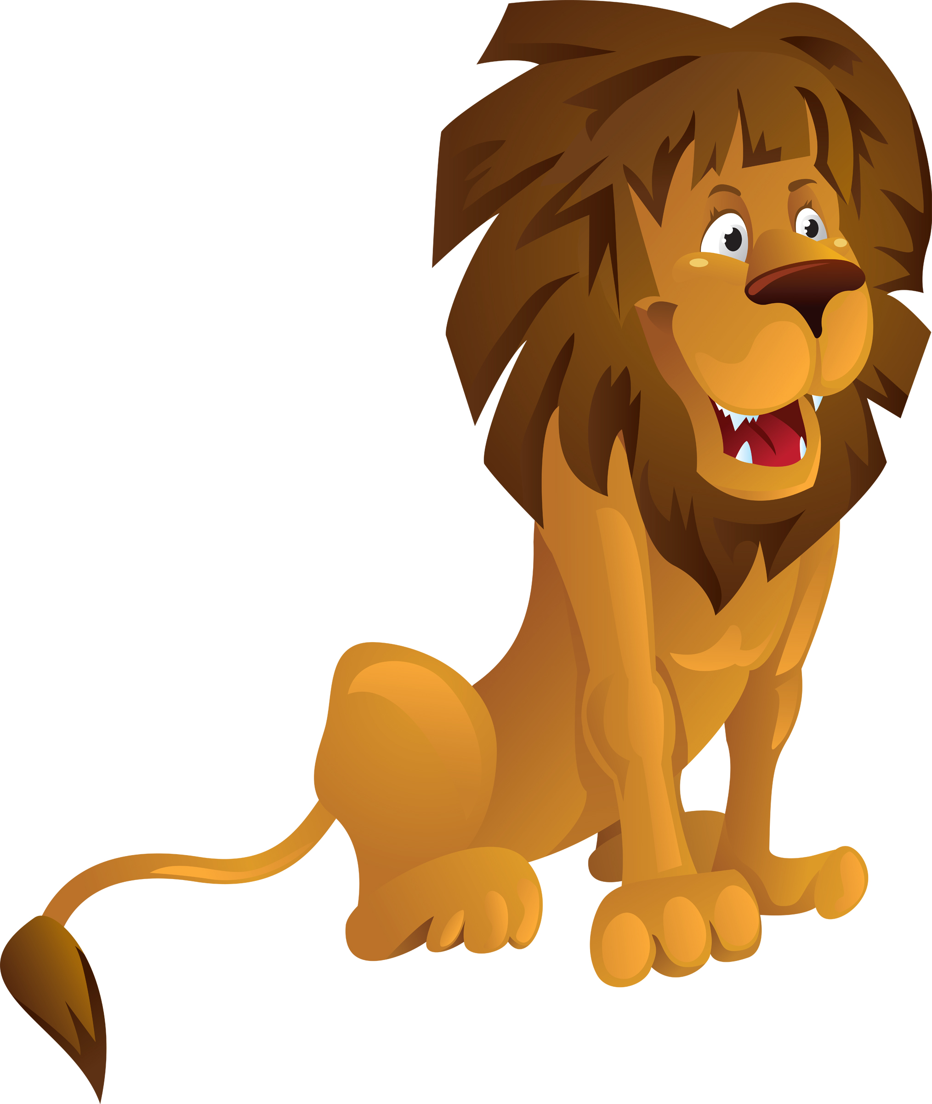

Did You See That? Skit
I added in some real jungle animals and birds and a single fact on each. Here are some ideas for other animals -
Parrot - who can imitate our voices
Eagles - the symbol of America
Lion - the king of the beast
Hippo - the water horse
Stanley, in a strong European accent, Hello there, I am Arthur Stanley Livingstone, the world famous explorer And we are all going on a photographic safari today
Boys, not really paying attention "H'lo"
Stanley "We are here today on location in the midst of the African rain forest, and we should see some rare species indeed! I can hardly contain myself. It is so exciting isn’t it?
Boys "Oh. Uh, yeah."
Stanley slowly, carefully stalks along, looking around, listening for the slightest peep. Boys shuffle after him.
Stanley, turning around, staring with wide open eyes for a second, then jumping up and down "Did you see that!! Did you see that!!"
Boy #1 - "Er, what"
Stanley "You mean you missed it?"
Boy #1, pauses, then admits it "uh, yeah"
Stanley "Well! My word. Todd, that was a Tamarin Monkey. They are very rare, in fact two species, The golden Lion and the Cotton Top are on the endangered species list
Stanley continues his slow stalking and looking around,
boys follow after him.
Stanley, stopping and looking up wide-eyed. Boys walk into him. "Did you see that!! Did you see that!!!"
Boy #2 "Er, um, well"
Stanley, somewhat cross "Well?"
Boy #2 "No."
Stanley, after a long sigh "Now that, my dear boy, was a Toucan with his bright yellow beak. They are very noisy and often sound like a frog croaking.
Stanley continues his slow stalking and looking around, boys follow after him.
Stanley, stopping and looking up wide-eyed. Boys walk into him. "Did you see that!! Did you see that!!!"
Boy #3 "Er, um, well"
Stanley, "Well?"
Boy #3 "No."
Stanley, after a long sigh "Now that, my dear boy, was a Malay Fruit Bat. It is rare to see them in daylight. They usually only travel at night using their personal sonar to avoid flying into trees and stuff.
Stanley and boys continue their pacing about the stage (make up some more items for other boys)
Stanley, turning around and yelling at Boy # X "Did you see that!! Did you see that!!!"
Boy #X, deciding to be clever "Er, um, ah, yes! Yes, I did see that!"
Stanley "Then why in the blazes did you step in it?"

I can Lick 10 Lions Skit
Narrator (does all the talking while hunter and lions act out the parts)

Lion Costume: Fringe material or crepe paper to put around face of lions. A tail could be hooked on the back at the waist.

(Hunter flexes muscles) I feel great! Simple great!
I can lick 10 lions today. (10 lions appear)
Well, maybe only nine.
Will you please step out of line? (One lion leaves)
I can lick 9 lions today. (Lions come closer)
Well, that's sort of a mean thing to do.
I'll cut my list.
First one dismissed. (One leaves)
I'll beat up the next eight.
I can lick 8 lions today. (Lions move closer)
Well---maybe just seven.
You, in the front row. You're excused.
You may go. (One lion leaves)
Your fingernails aren't very clean. (Points to another)
I can lick 6 lions today.
Well---quite a few of you are underweight.
It's not fair, after all, to lick lions so small.
I think that I'll only lick 5.
I can lick 5 lions today.
Well, you look sort of sleepy to me.
Some of you chaps should go home and take naps.
I only intend to lick 4. (One leaves).
I can lick 4 big lions today.
Well, it's frightfully hot in the sun.
You two, I'm afraid should be down in the shade (Two leave).
I can lick two lions today.
Two lions would make such a little fight. (One leaves)
I can lick one lion today.

Lion: Grrrr. Grrrrr.

Narrator: But you know I have sort of a hunch that noontime is near. You just wait for me here. I'll beat you up right after lunch.

(Lion chases hunter off stage).

The Lost Pet
(This skit can also be played by one person by wearing two different hats and crouching as a boy and looking downward as a man.)
Boy: (Enter crying, dragging a dog leash) Waaaaaah! Waaaaaah! Man: Little boy, what’s the matter?
Boy: My pet ran away! Waaaaaah!
Man: Don’t cry, little boy. I’ll help you find it. What color is your pet? Boy: Yellow, with black stripes. Waaaaaah!
Man: Don’t cry, little man, I’ll have your pet back in no time.
(Search about the stage, muttering to self) Yellow with black stripes...hmmm... Boy: I want my pet! Waaaaaah!
Man: Maybe he wandered down the street. You just wait here while I go look for him.
(Exit, quickly put on a ragged coat, muss up hair. Enter, running, shouting) Why didn’t you say it was a TIGER? (Exit, running.)

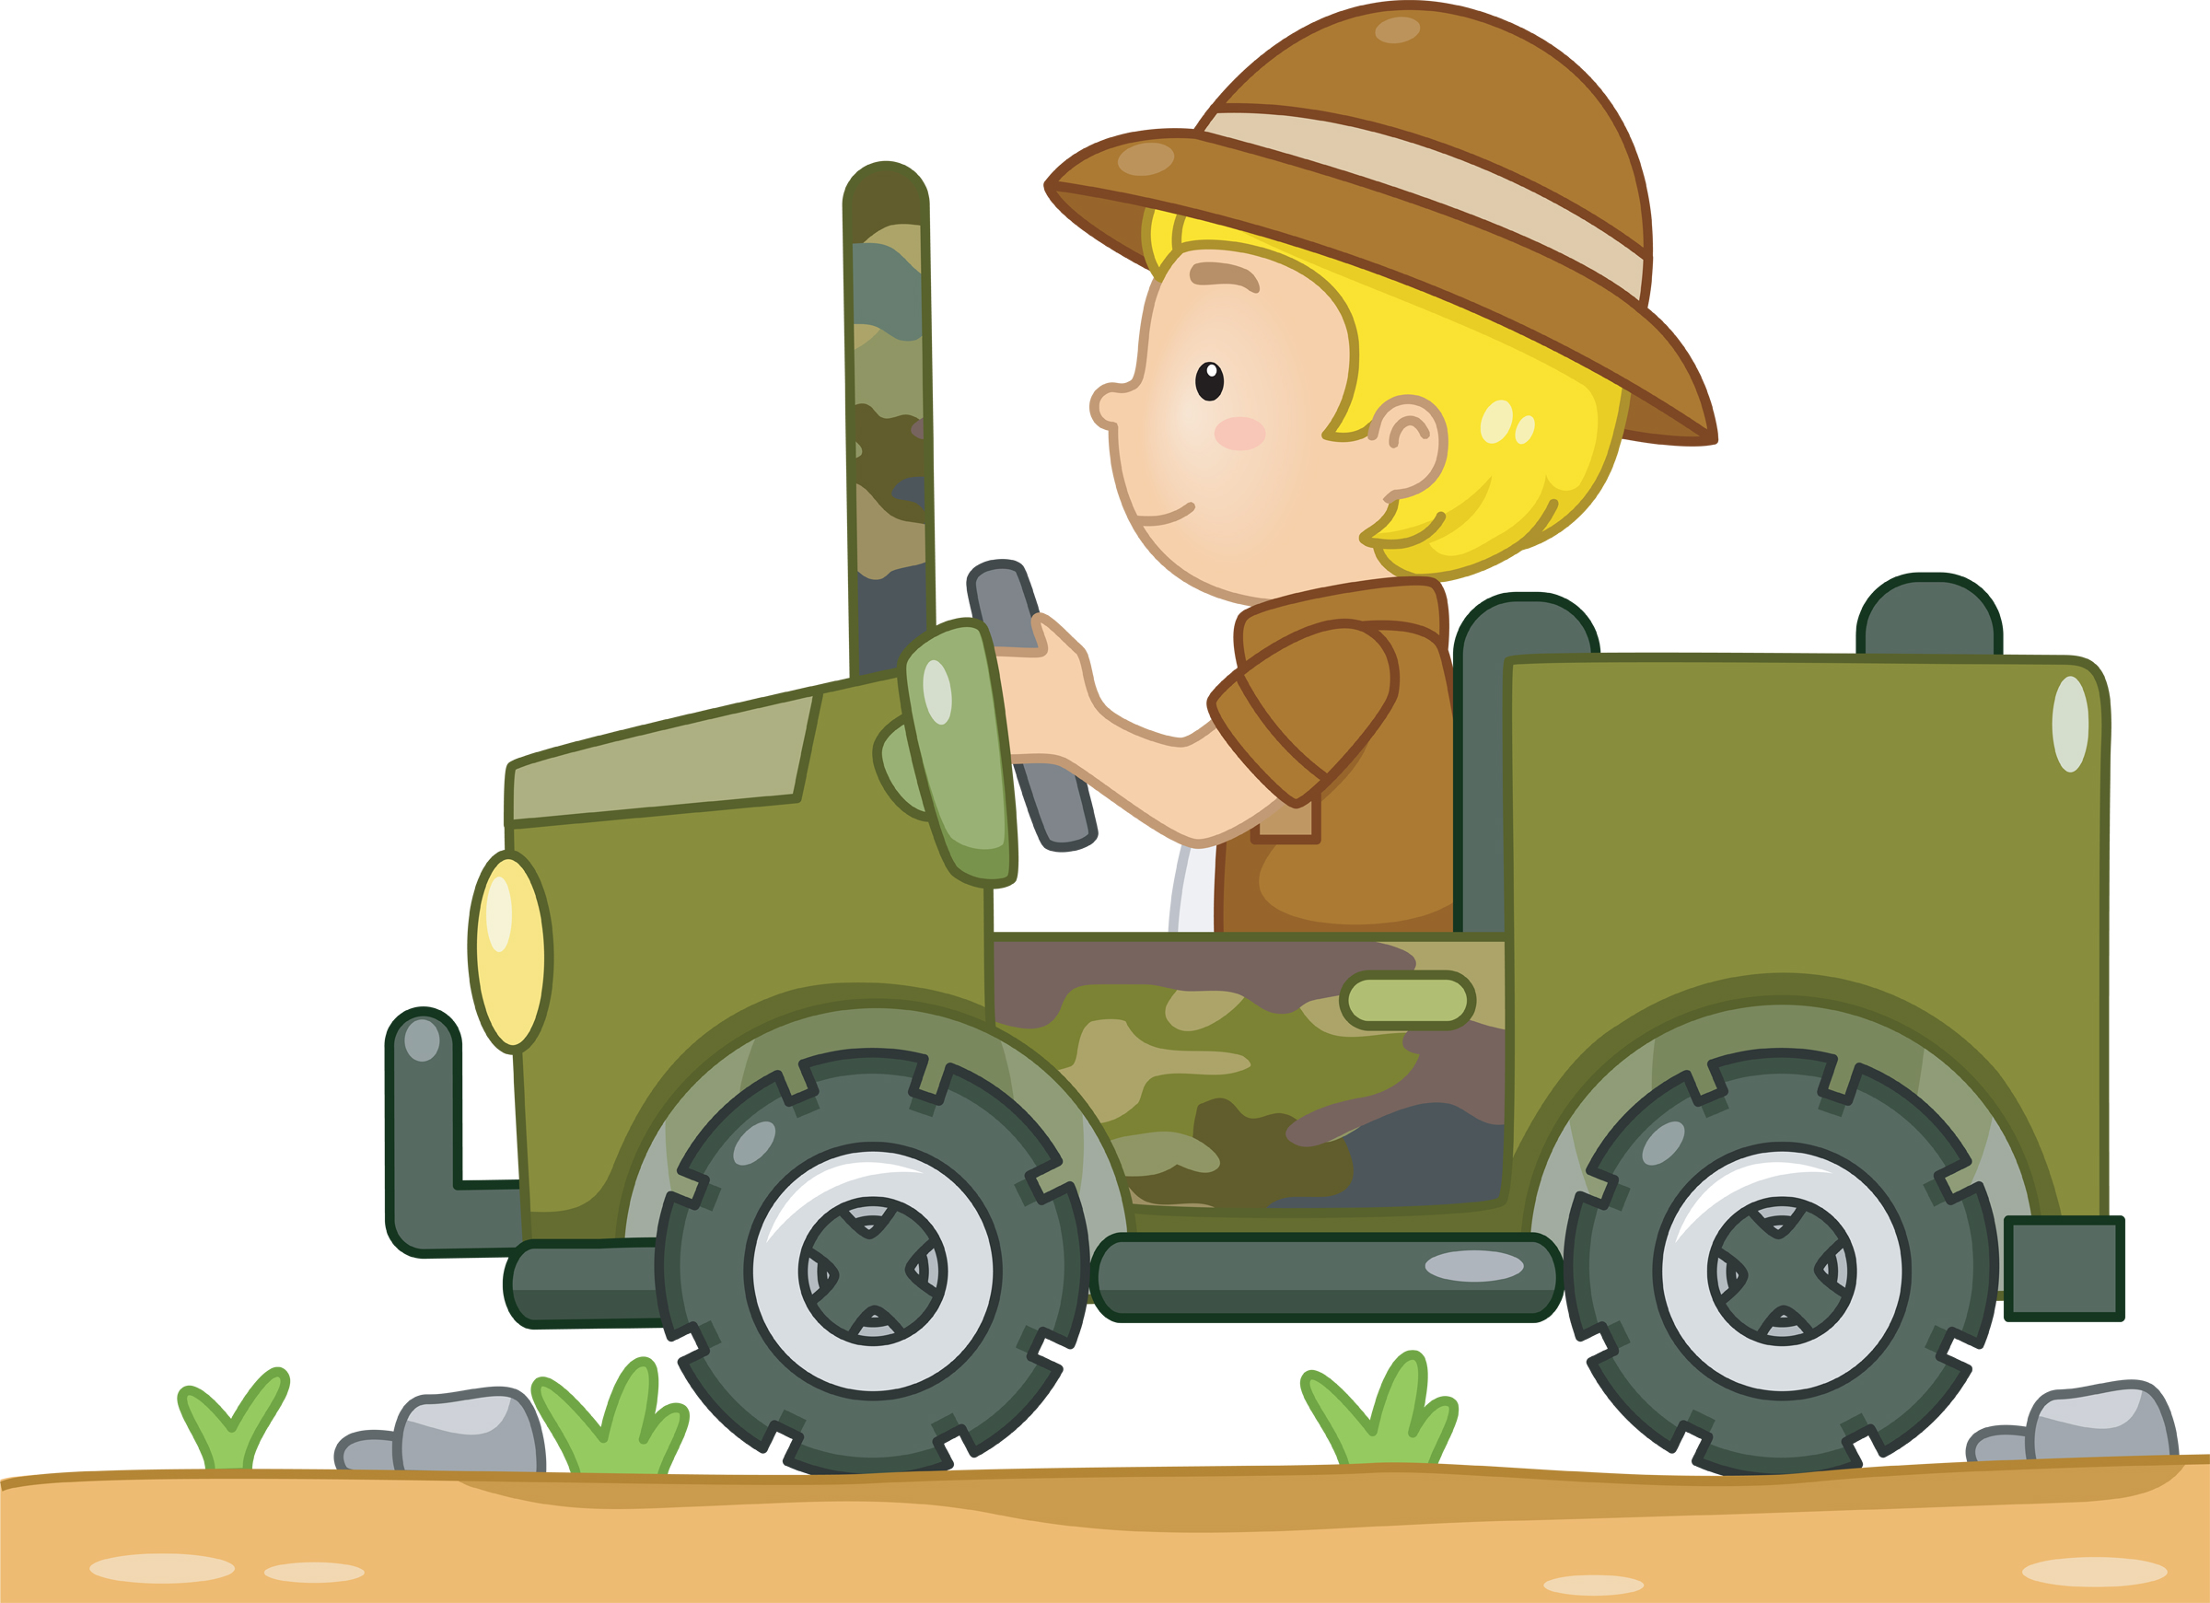
A Jungle Book Skit
Setting: Lights out, artificial fire, spotlight, 3 Scouts around the campfire.
#1: The forest is quite beautiful tonight, filled with friends and danger.
#2: Yes, it reminds me of a book I read as a boy, “The Jungle Book,” by Rudyard Kipling.
#1: I think I remember that book. Wasn’t that the story of a lost boy adopted by a wolf pack?
#2: Yes, the wolves named him Mowgli, meaning “Little Frog,” because his skin was smooth and hairless.
#3: How did Mowgli come to live among the wolves?
#2: He wandered away while Shere Khan was terrifying his village.
#3: Who is Shere Khan?
#2: Shere Khan was the great tiger bully—all stripes, teeth, and claws—and, like most bullies, not very brave when confronted.
#3: Was Mowgli immediately accepted into the wolf pack?
#2: No, Mowgli, the man-cub, had to get the approval of the pack and Akela. Two animals had to speak up for him.
#3: Who is Akela?
#2: Akela was the wise old wolf – the head of the pack. He saw that the younger wolves all kept the Scout Law.
#3: What animals spoke up for Mowgli?
#2: The first to speak was Baloo, the serious old bear who taught young wolves the Scout Law. The second was Bagheera, the cunning black panther, who taught the skills of the pack.
#3: Were there other animals in the story?
#2: Yes, there was Hathi, the elephant, and the Bandor-log.
#3: The Bandor-log?
#2: Yes, the Bandor-log were the monkey people. They obeyed no laws. They were not brave; they fought only if they greatly outnumbered their foes.
#3: Any other animals?
#2: There was Tabaqui, the dish licker—the mean, sneaky jackal who made friends by using flattery so he could get food from them. And there Kaa, the great serpent, who appeared slow and good-natured; but, anyone who joined the Bandor-log was soon swallowed up by Kaa. Some say his real name is Laziness.
#1: You know Lord Baden-Powell used “The Jungle Book” as the basis of Cub Scouts.
#3: I never knew that.
#1: Well, it’s true. There were many boys wanting a program that were too young for Boy Scouts. Baden-Powell called them “Wolf Cubs.” Boy Scouts were called wolves after the Indian name for Scout. And young Scouts are young Wolf cubs.
#3: What things did Baden-Powell use from the Jungle Book?
#2: The Scout Oath is like the wolf’s solemn promise, and the Scout Law is like the law of the jungle. Even the two fingers of the Cub Scout sign represent the two ears of the wolf. Many Cub Scout ceremonies and patches still show their “Jungle Book” origins.
#3: Aha—so that is how Cub Scouting was started.

Magic Mud Skit
Setting – 7 Scouts
Scene – Sign in center of stage is marked “Mud Puddle.” Scouts enter and gather around the sign.
Cub #1: Did you ever wonder as you pass a little stretch of mud and grass what nature may be hiding there, within this spot of a few feet square? Let’s gather around and take a look and like the pages in a book, we’ll study it with open eyes. Can mud like this hold any surprises?
Cub #2: Here is a freshly patterned animal track, where a rabbit hopped across and back.
Cub #3: I see a line of busy ants, carrying tidbits of food upon their backs.
Cub #4: Look, I found a feather that’s blue and gray, probably from a low flying blue jay.
Cub #5: Sprinkled here are signs of sprouting seeds from lofty trees and sprawling weeds.
Cub #6: A pebble smoothed by nature’s action slow, formed a million years ago.
Cub #7: In a puddle spot not yet dried out, a water beetle swims about.
Cub #2: And here an eager plant is set – an early blooming violet.
Cub #3: A wiggly worm come up to twitch, how do we tell which end is which?
Cub #4: The mud itself with food stores vast, from life that flew in ages past.
Cub #5: It’s not all nurture mud reveals. Here’s a candy wrapper and two toy wheels.
Cub #6: There’s something moving – what’s that now? I’ll pick it up, a Bee, YOW!
Cub #7: Quick, here’s some mud upon the spot, to take away the soreness hot.
Cub #1: In mud there’s stone and living things, healing power for bitter stings. Through it flows the earth’s life blood; our mud is really Magic Mud!

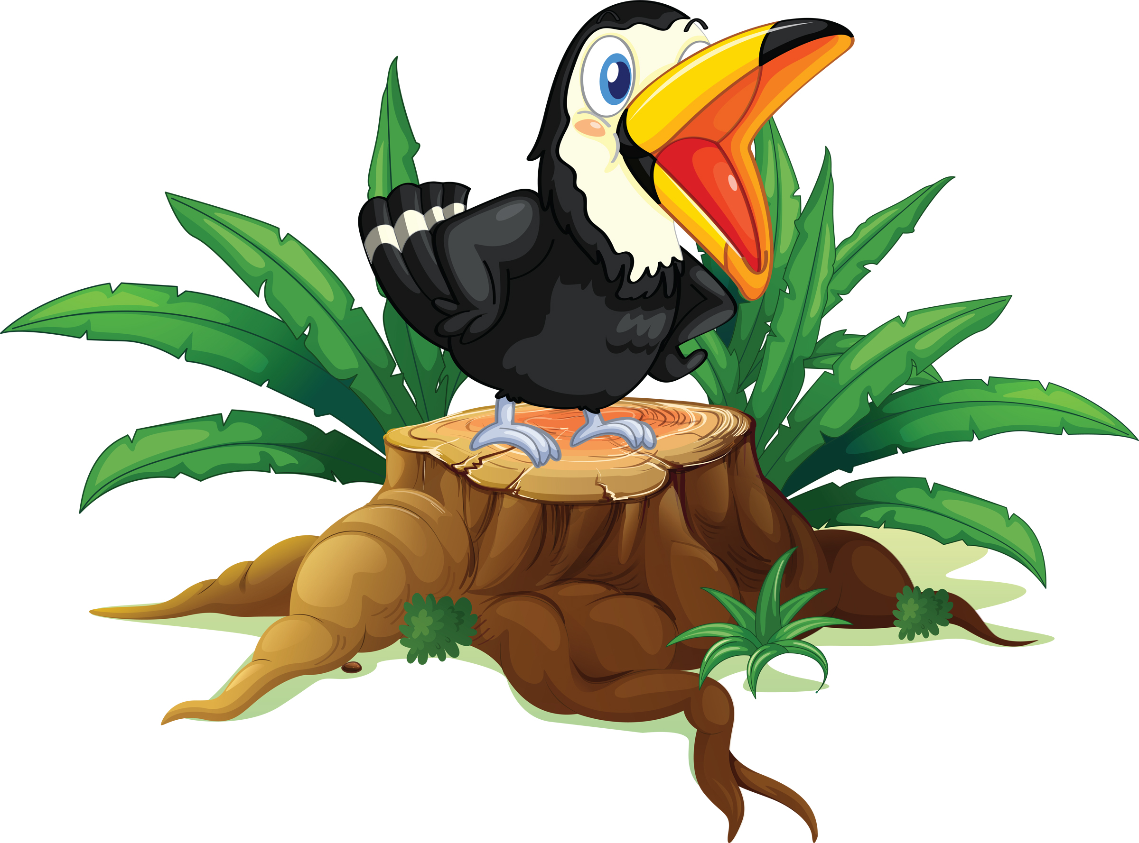
We're Going On Safari
This is an action chant, which can be performed by as many scouts as you wish. It can be made into something really good, by dressing up in safari gear and carrying rifles.

Cub #1: We're going on safari.
All: We're going on safari.
Cub #1: We're gonna catch a big one.
All: We're gonna catch a big one.
Cub #1: Ooh look a snake.
All: Ooh look a snake.
Cub #1: Hiss, hiss.
All: Hiss, hiss.

Cub #2: We're going on safari.
All: We're going on safari.
Cub #2: We're gonna catch a big one.
All: We're gonna catch a big one.
Cub #2: Ooh look a crocodile.
All: Ooh look a crocodile.
Cub #2: Snap, snap.
All: Snap, snap.
Cub #1: Hiss, hiss.
All: Hiss, hiss.

Cub #3: We're going on safari.
All: We're going on safari.
Cub #3: We're gonna catch a big one.
All: We're gonna catch a big one.
Cub #3: Ooh look a panther.
All: Ooh look a panther.
Cub #3: Poof, poof.
All: POOF, POOF.......Why on Earth poof poof?
Cub #3: Well, he was pink!
Cub #2: Snap, snap.
All: Snap, snap.
Cub #1: Hiss, hiss.
All: Hiss, hiss.

AND SO ON.

To finish you can have someone dressed in a gorilla suit. The last scout starts to sing ooh look a gorilla, then all the others see the gorilla as he comes on stage and chases them all off screaming.

DECORATIONS

Decorations emphasize the theme and help set the mood. Theme-related music playing in the background also helps set the atmosphere. This month, make trees from brown paper bags by crushing them down and stacking them. Add green tissue paper for leaves. Decorate around the entry door, too. Place stuffed animals and hang pictures around the room. Play a sound track with sounds of monkeys and elephants for a real safari feel.

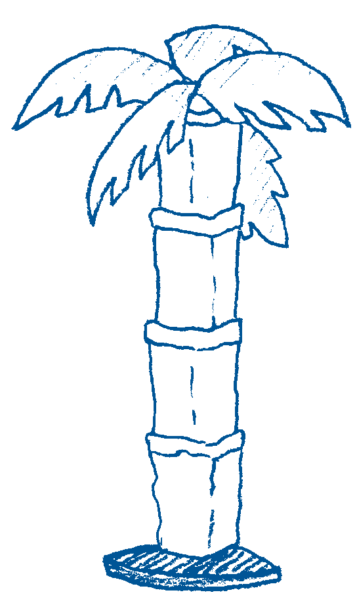
Create a Palm Tree
Materials: Brown paper bags, green construction paper, tape; tree base made from a lamp stand or a 5- to 6-foot dowel rod or PVC pipe secured in a bucket of plaster of Paris
Start with five brown paper bags. Cut a hole in the bottom of each bag. Slide over the tree base, setting one bag atop another. To sculpt the bags to resemble the trunk of a palm tree, fold the back part over upon itself and secure with tape. For palm fronds,
cut and notch oval shapes from green construction paper and tape to the top of the structure.

Place your paper bag trees on the stage area where awards will be presented
Alternate method: Wrap the pole or lamppost with brown paper and then draw hash marks to resemble the distinctive bark seen on trimmed palm trees.

Make a vine
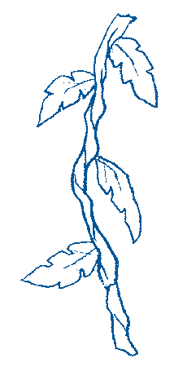
Cut brown paper bags into 3-inch strips. Crumple and twist the strips to form a 1-inch-diameter length resembling a vine’s woody stem. Attach lengths of crumpled strips end-to-end to make one or more long vines. Add leaves cut from construction paper. For authenticity, consult library books or other reference materials to copy the leaf shapes typically found on tropical vines.

Drape vines along the walls, across the ceiling, and above the greeting and refreshment areas. Decorate around the entrance door with vines and leaves.

Source: www.pinterest.com/pin/AbS1oRApckoyHzCEEBby0k4Pai-QTAXoWp77lqbYQ965p1btIvIQwFY/
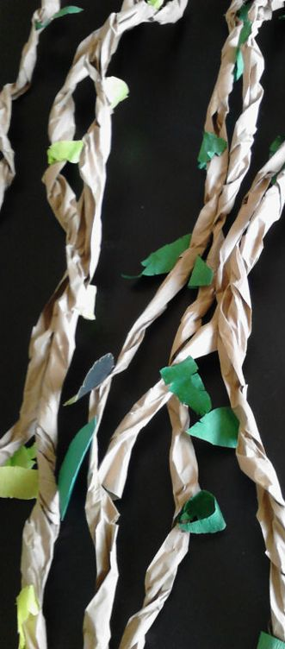
Paper Plate Safari Hats
Source: http://widgetworm.blogspot.com/2008/10/paper-plate-safari-hats.html
Materials: Vanity Fair plastic bowls and plates, hole punch, scissors, twine, spray paint, hot glue gun

Trace the shape of the bowl onto the plate and cut the hole slightly smaller. Hot glue them together. Add spray paint and twine.

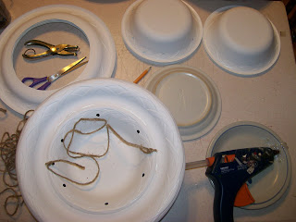

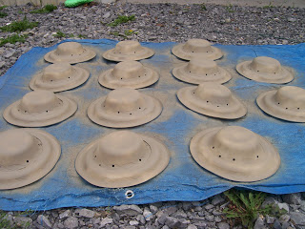

Binoculars
Instructions: www.pinterest.com/pin/71635450300028659/

Souce: http://meandmyinsanity.com/2012/10/coffee-filter-lion-preschool-craft.html/toilet-paper-roll-binoculars-3882
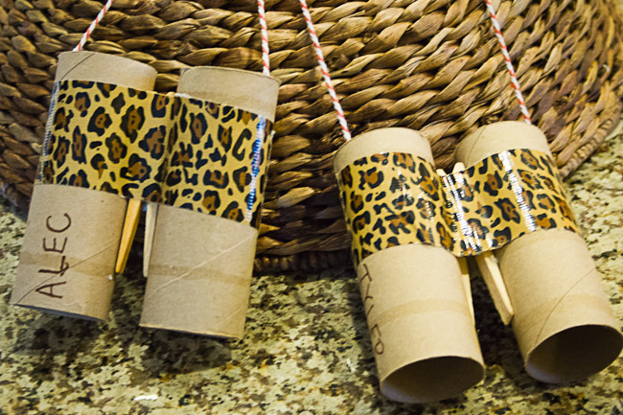

Jungle Themed Decoration Ideas
Source http://grassybranchfarms.blogspot.com/2013/05/camp-tarzan.html

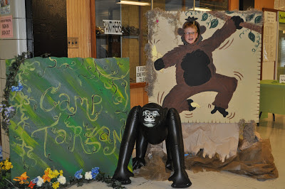

Source: http://catchmyparty.com/photos/1248642
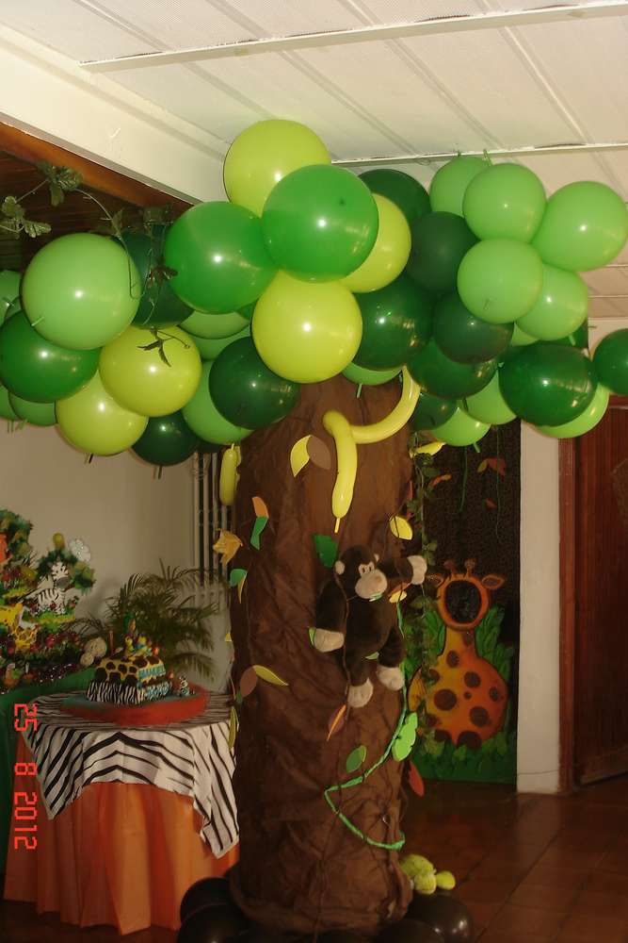
Source: https://www.pinterest.com/pin/213639576046426784/
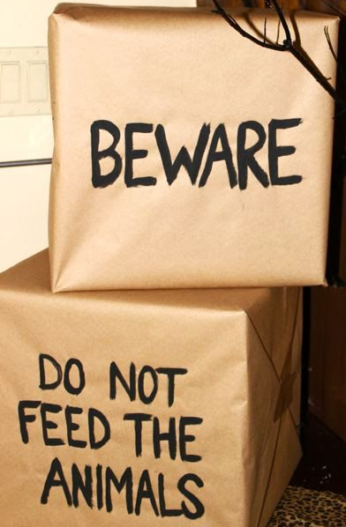

Jungle vines made from dollar store table cloths, cut into strips. www.pinterest.com/pin/514184482431919441/

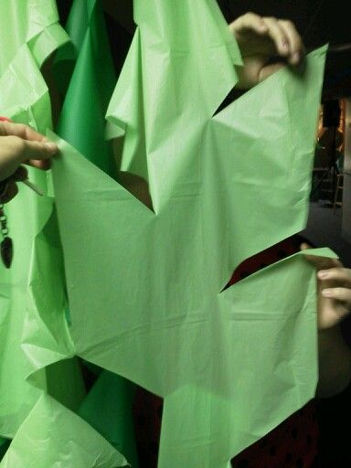
Source: www.pinterest.com/pin/107312403596995224/
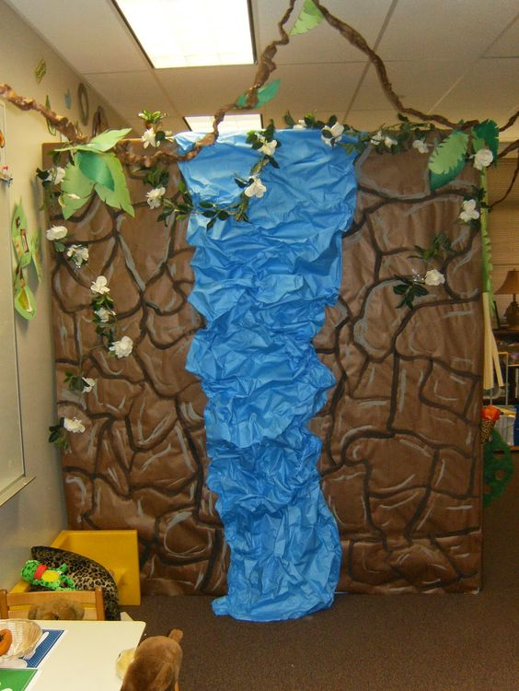
Source: www.pinterest.com/pin/534169205773820398/
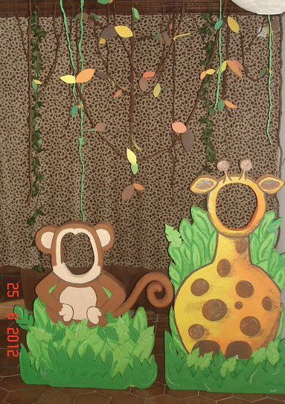

www.pinterest.com/pin/508977195368316953/

www.pinterest.com/pin/70437472304719/
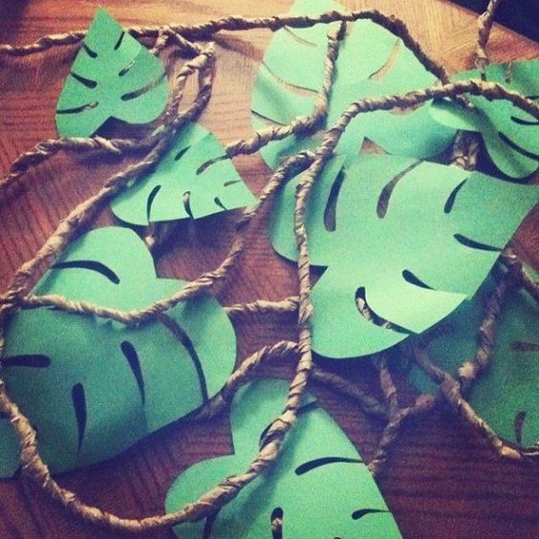

www.pinterest.com/pin/137430226109270728/
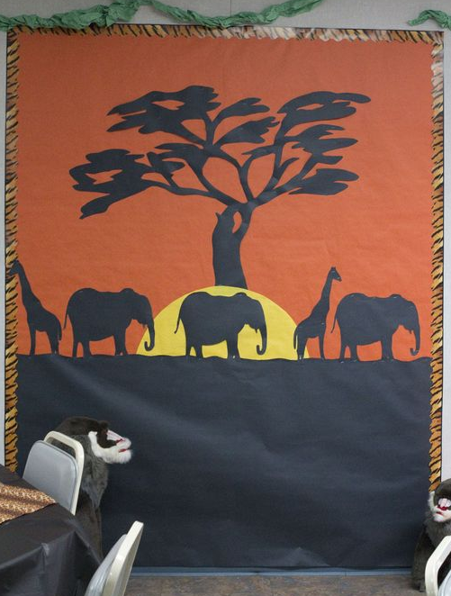

Source: www.pinterest.com/pin/371476669234257579/
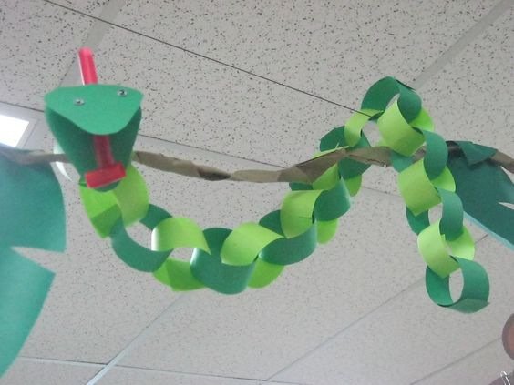

Jungle Word Search

X | U | E | X | P | A | R | R | O | T | I | G | E | R | D
M | V | H | Q | A | L | L | I | R | O | G | O | Z | Z | R
D | T | J | W | G | E | P | S | I | A | J | V | S | J | X
T | U | S | C | H | E | E | T | A | H | E | M | I | H | H
K | L | T | Y | R | S | G | O | R | F | S | N | A | K | E
O | E | O | K | H | O | O | O | F | P | D | G | H | R | U
U | O | X | U | I | D | C | A | M | S | R | O | Q | W | R
X | P | R | C | N | D | R | O | A | D | A | F | S | E | R
C | A | O | A | O | I | N | P | D | R | Z | E | B | R | A
L | R | P | G | G | K | X | P | N | I | I | S | A | J | Z
Y | D | T | O | E | N | S | I | A | B | L | I | O | N | T
Y | E | C | Y | T | N | A | H | P | E | L | E | W | Q | D
N | C | Z | E | A | L | O | K | S | P | I | D | E | R | C
P | Y | L | B | S | R | A | E | B | T | O | H | M | E | W
E | C | D | X | O | W | M | U | H | J | W | R | G | Q | J

BEARS | BIRDS | CHEETAH | CROCODILE
ELEPHANT | FROGS | GIRAFFE | GORILLA
HIPPO | KANGAROO | KOLA | LEOPARD
LION | LIZARDS | MONKEY | PANDA
PARROT | RHINO | SNAKE | SPIDER
TIGER | ZEBRA

PROGRAM

Print the program front to back.

An editable, word version of this document is available at www.day-camp.shac.org/jungle-theme

Check back frequently for updates.

Upcoming Events

February 11, 2017 University of Scouting (leader training; www.shac.org/uos)

March xx, 2017 Pack Meeting

April xx, 2017 Pack Meeting

May 5, 2017 Scout Fair (shac.org/scout-fair)
May xx, 2017 Pack Meeting

June xx, 2017 Day Camp (www.shac.org/day-camp)

July xx, 2017 Pack summer time activity #2
July Resident Camp (www.shac.org/resident-camp)

August xx, 2017 Pack summer time activity #3

Communication Tools

Pack website
Pack Facebook page

District website
District Facebook page

www.shac.org
www.facebook.com/shac.bsa
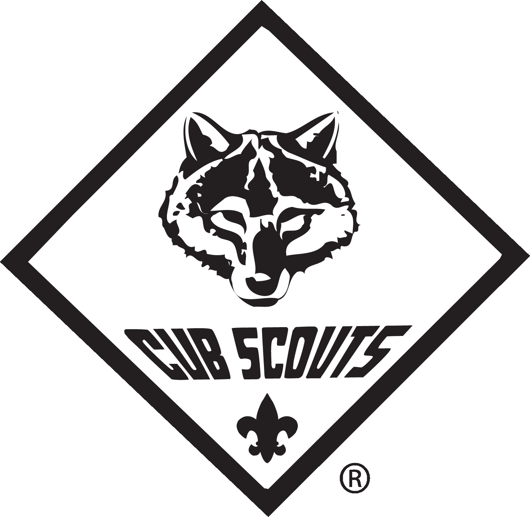
Pack 123
Blue and Gold
Banquet

February 1, 2017

Gathering
The Jungle Hokey Pokey
(Tune: Hokey-Pokey)

You put your Tiger foot in, you put your Tiger foot out, you put your Tiger foot in, and you shake it all about. You do the Hokey-Pokey and you turn yourself around. That’s what it’s all about.
(More verses: Monkey’s hand; Zebra tail; Giraffe’s neck; Toucan beak; Elephant’s trunk; Lion’s mane)

Take Me Out to The Forest
(Tune: Take Me Out to The Ballgame)

Take me out to the forest. Let me hike in the wild.
Show me a skunk and a few bear tracks. I won't care if I never come back.
But it's look, look, at your compass. If it rains, then your wet.
And its ouch, slap, sting and you're bit in the great outdoors.

The Coming of the Frogs
(Tune: Battle Hymn of the Republic)
Mine eyes have seen the horror of the coming of the frogs,
They are sneaking thru the swamps and they are lurking in the logs.
You can hear their mournful croaking through the early morning fog.
The frogs keep hopping on.

Chorus: (repeat after each verse)
Ribet, ribet, ribet, croak, croak.
Ribet, ribet, ribet, croak, croak.
Ribet, ribet, ribet, croak, croak.
The frogs keep hopping on.

The frogs have grown in numbers and their croaking fills the air.
There's no place to excape because the frogs are everywhere.
They've eaten all the flies and now they're hungry as a bear
The frogs keep hopping on. Chorus

They've hopped into the living room and headed down the hall,
They have trapped me in the corner and my back's against the wall.
And when I opened up my mouth to give the warning call,
This was all I heard. Chorus

Welcome Name
Cubmaster

Opening Webelos
Den 6

Flag Ceremony Webelos
Den 4

Invocation Name
Title

Dinner

FOS Presentation Name
Title

Advancement Ceremony Name
Cubmaster

Song Wolves
Den 1

Leader Recognition Name
Committee Chair

Skit Tigers
Den 3

Cubmaster Minute Name
Cubmaster

Closing Bears
Den 5
Upcoming Events
Pack 123
Blue and Gold
Banquet

February 1, 2017

February 11, 2017 University of Scouting (leader training; www.shac.org/uos)

March xx, 2017 Pack Meeting

April xx, 2017 Pack Meeting

May 5, 2017 Scout Fair (shac.org/scout-fair)
May xx, 2017 Pack Meeting

June xx-xx, 2017 Day Camp (www.shac.org/day-camp)

July xx, 2017 Pack summer time activity #2
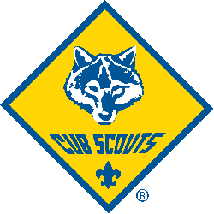
July 2017 Resident Camp (www.shac.org/resident-camp)

August xx, 2017 Pack summer time activity #3

Communication Tools

Pack website
Pack Facebook page

District website
District Facebook page

www.shac.org
www.facebook.com/shac.bsa
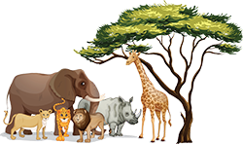
Gathering

Welcome Name
Cubmaster

Opening Webelos
Den 6

Flag Ceremony Webelos
Den 4

Invocation Name
Title

Dinner

FOS Presentation Name
Title

Advancement Ceremony Name
Cubmaster
Song Wolves
Den 1

Leader Recognition Name
Committee Chair

Skit Tigers
Den 3

Cubmaster Minute Name
Cubmaster

Closing Bears
Den 5

The Jungle Hokey Pokey
(Tune: Hokey-Pokey)
You put your Tiger foot in, you put your
Tiger foot out, you put your Tiger foot in,
and you shake it all about.
You do the Hokey-Pokey and you
turn yourself around.
That’s what it’s all about.
(More verses: Monkey’s hand;
Zebra tail; Giraffe’s neck; Toucan beak;
Elephant’s trunk; Lion’s mane)

Take Me Out to The Forest
(Tune: Take Me Out to The Ballgame)
Take me out to the forest. Let me hike in the wild.
Show me a skunk and a few bear tracks.
I won't care if I never come back.
But it's look, look, at your compass.
If it rains, then your wet.
And its ouch, slap, sting
and you're bit in the great outdoors.

The Coming of the Frogs
(Tune: Battle Hymn of the Republic)
Mine eyes have seen the horror of the coming of the frogs,
They are sneaking thru the swamps and they are lurking in the logs.
You can hear their mournful croaking through the early morning fog.
The frogs keep hopping on.

Chorus: (repeat after each verse)
Ribet, ribet, ribet, croak, croak.
Ribet, ribet, ribet, croak, croak.
Ribet, ribet, ribet, croak, croak.
The frogs keep hopping on.

The frogs have grown in numbers and their croaking fills the air.
There's no place to excape because the frogs are everywhere.
They've eaten all the flies and now they're hungry as a bear
The frogs keep hopping on. Chorus

They've hopped into the living room and headed down the hall,
They have trapped me in the corner and my back's against the wall.
And when I opened up my mouth to give the warning call,
This was all I heard. Chorus

